Assignment 17
Layer 3 Switch Inter-VLAN Routing

Shreya Panchal
Topic: Inter-VLAN Routing using a Layer 3 Switch, Switch Virtual Interfaces (SVIs), IP Routing Hardware Acceleration

Theory Overview

1. Inter-VLAN Routing using a Layer 3 Switch
A Layer 3 Switch (Multilayer Switch) combines the high-speed data-forwarding capabilities of a Layer 2 switch with the specialized routing functions of a traditional router. Unlike the "Router-on-a-Stick" model, which relies on a single external physical interface bottleneck, a Layer 3 switch processes inter-VLAN data directly on its hardware using internal Application-Specific Integrated Circuits (ASICs), providing faster data transfer rates and scalable bandwidth.

2. Switch Virtual Interfaces (SVIs)
A Switch Virtual Interface (SVI) is a logical Layer 3 interface configured for a specific VLAN on a multilayer switch. To enable communication between different subnets without an external router, each SVI is assigned an IP address that acts as the default gateway for all host machines connected within that VLAN segment.

Tasks & Answers

Task 1: Create VLANs and Assign Interfaces on a Layer 3 Switch
Question: On a Cisco Layer 3 switch, create three VLANs (e.g., VLAN 10 for 'Sales', VLAN 20 for 'Support', VLAN 30 for 'Marketing') and assign at least one interface to each VLAN.
Answer:

VLAN Assignment Matrix
VLAN | Name | Subnet Allocation | Interface
10 | Sales | 192.168.10.0/24 | FastEthernet0/1
20 | Support | 192.168.20.0/24 | FastEthernet0/2
30 | Marketing | 192.168.30.0/24 | FastEthernet0/3

CLI Configuration Commands
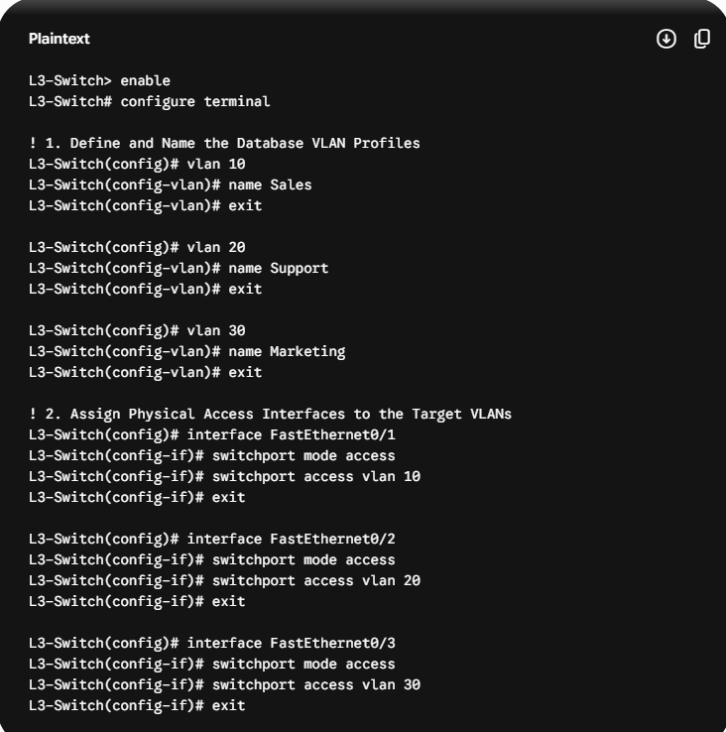

Task 2: Configure Switch Virtual Interfaces (SVIs)
Question: Configure Switch Virtual Interfaces (SVIs) for each VLAN you created by assigning them unique IP addresses (e.g., 192.168.10.1/24 for VLAN 10, etc.) and ensure each SVI is in 'up/up' state. Hint: Use the interface vlan command to create SVIs and no shutdown to enable them.
Answer:

CLI Configuration Commands
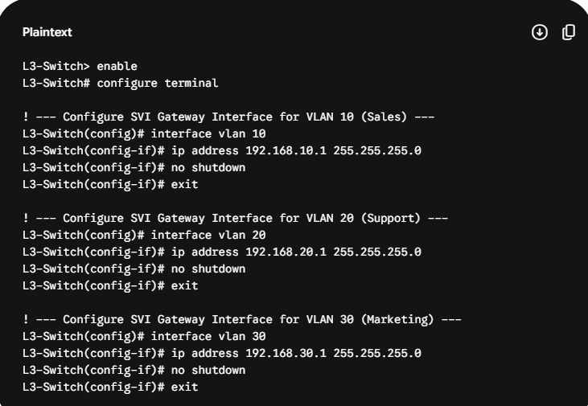
Note: To ensure the SVIs go into the operational "up/up" status, at least one physical port assigned to each respective VLAN must be connected to an active, powered-on device.

Task 3: Enable Global Layer 3 IP Routing
Question: Enable IP routing on the Layer 3 switch so that devices in different VLANs can communicate with each other without using an external router. Hint: Use the ip routing global configuration command.
Answer: By default, multi-layer switches function strictly as Layer 2 devices. To activate its internal routing engine and pass traffic between the configured SVIs, the global routing command must be explicitly entered.

CLI Configuration Commands
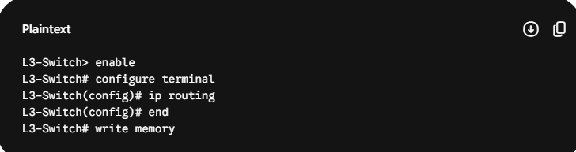

Task 4: Verification of Inter-VLAN Connectivity
Question: Verify inter-VLAN routing by connecting two PCs (one in VLAN 10 and one in VLAN 20) and pinging between them. Capture and submit the ping results to show successful communication.
Answer:

Node Settings
Node | IP Address | Gateway
PC-Sales (VLAN 10) | 192.168.10.10 | 192.168.10.1
PC-Support (VLAN 20) | 192.168.20.10 | 192.168.20.1

Ping Test Execution
Open the Command Prompt on PC-Sales and run the ping test to the PC-Support machine:
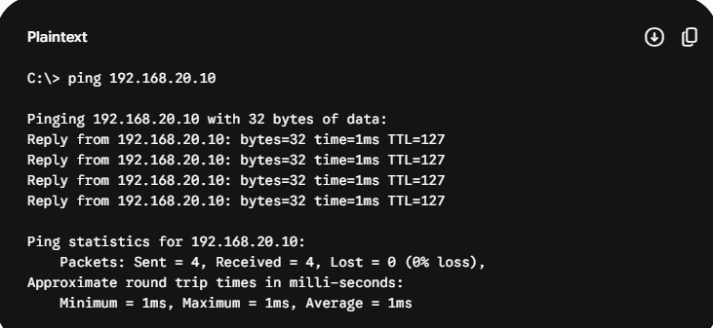
The ping succeeds because the switch processes the packet, recognizes the destination is on a different SVI network, and routes the traffic internally at hardware speed.

Task 5: Refactoring Subnet Masks (VLSM Optimization)
Question: Refactor your VLAN and SVI configuration so that VLAN 30 uses a different subnet mask (e.g., /25 instead of /24). Explain what changes you made and how this affects communication with the other VLANs.
Answer:

Step 1: CLI Refactoring Commands on SVI 30
We change the host range of the Marketing VLAN from a standard Class C /24 mask (255.255.255.0) to a Variable Length Subnet Mask (VLSM) /25 mask (255.255.255.128).
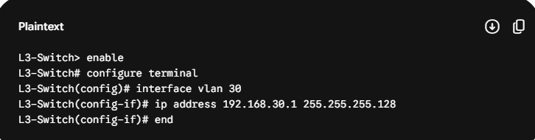

Step 2: Operational Structural Analysis
What Changes Were Made: The subnet pool for VLAN 30 was split in half. Instead of holding up to 254 usable host addresses (192.168.30.1 to 192.168.30.254), the new /25 mask restricts the usable host range from 192.168.30.1 to 192.168.30.126.
Effect on Communication with Other VLANs: This adjustment does not break or disrupt communication with the other VLANs (VLAN 10 and VLAN 20). Because the ip routing engine is active, the switch automatically updates its routing table to look for the narrower /25 route when handling traffic for VLAN 30. As long as the host devices inside VLAN 30 update their subnet masks to match the new 255.255.255.128 gateway setting, they will continue to communicate with the rest of the network without any connectivity issues.

